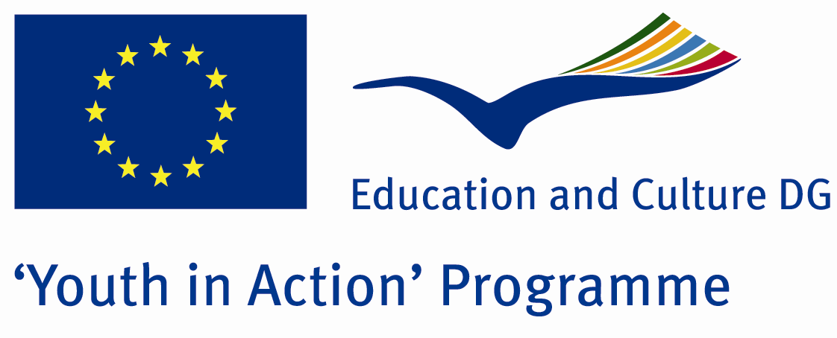

We’re Living Together



ACTION 4.3 – TRAINING AND NETWORKING

13-19th August, 2011

Duzce, TURKEY

ACTION 4.3 – TRAINING AND NETWORKING
13-19th August, 2011
Duzce, TURKEY

Please contact directly to;
adventurerpeacepigeons@gmail.com

Project Summary; This project is about the minorities and immigrants in Europe. The minorities and immigrants are in every country. They live with us together but in a different way. They have generally not enough rights and the discrimination against such social groups are raising. This problem have religious, national, socio-culturel and some other reasons. Many of these people can not belong themselves to the society in which they are living, generally for a long time. Even if they have the same passports, they are identified again by the society itself. So if you want to join us and discuss about this problem and contribute to solve it, come and do it.

Project Title; We’re Living Together

Date and Venue ; 13-19th August, 2011 Duzce, Turkey .

Target Group ; Municipalities, City Councils and Non-Governmental organizations,
youth groups,culture and art groups,e.t.c

Participants ; 5 people from each country (over 18 -25 ). Totally 8 countries.

Conditions ; Accommodation, board and programme costs will be financed through European Commission Youth in Action Programme (Action 4.3). Travel costs will be reimbursed in 70% (APEX Tarrifs). Organizations from all 27 EU member countries plus Liechtenstein, Norway and Iceland are eligible to take part.

Working language: English

Organizer; Discovery And Adventure Group

How to apply: If you are interested, please send your Part III forms to
0090 216 483 21 67 by FAX please. (Fulfilled Part III which you can find in the attachment, of course signed and stamped) ..

Note: jpeg is not allowed..please send by fax…

Next step 2;
Original send via regular post to this address please:

Ertan DERİN
Öner İnşaat
Abdulhalik Renda Cd.
Parlar Sk. No:4 Pendik/İSTANBUL

If you have any questions you may contact with: adventurerpeacepigeons@gmail.com

Deadline for application; until 20th January 2011.

For Further information:
Contact Person
Ertan DERİN
Öner İnşaat
Abdulhalik Renda Cd.
Parlar Sk. No:4 Pendik/İSTANBUL

e-mail : adventurerpeacepigeons@gmail.com
Mobile : 0090 542 393 93 90
Fax : 0090 216 483 21 67

